**PÁGINA:**

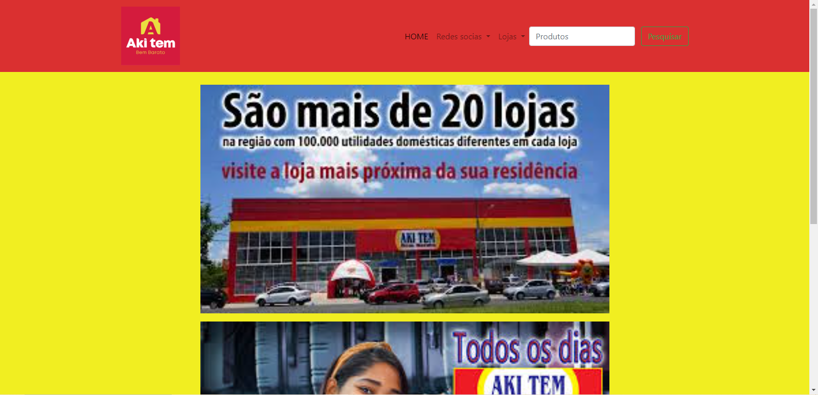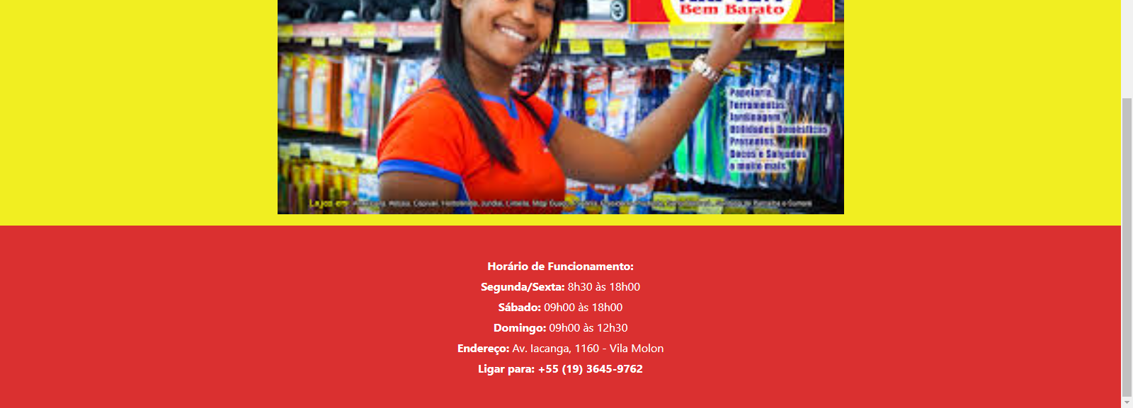

**CÓDIGO CSS:**

.loja {

text-align: center;

padding-top:25px;

}

.body {

border-left: -150px solid #da3030;

border-right: -150px solid #da3030;

background-color: #f1ee15f1;

}

footer {

background-color: #da3030;

color: #fff;

padding: 40px 20px;

text-align: center;

font-size: 16px;

}

footer p {

margin: 5px 0;

}

footer a {

color: #fff;

text-decoration: none;

font-weight: bold;

}

footer a:hover {

text-decoration: underline; }

**CÓDIGO HTML:**

<!DOCTYPE html>

<html lang="pt-br">

<head>

<meta charset="utf-8">

<meta name="viewport" content="width=device-width, initial-scale=1, shrink-to-fit=no">

<link rel="stylesheet" href="https://stackpath.bootstrapcdn.com/bootstrap/4.1.3/css/bootstrap.min.css"

integrity="sha384-MCw98/SFnGE8fJT3GXwEOngsV7Zt27NXFoaoApmYm81iuXoPkFOJwJ8ERdknLPMO" crossorigin="anonymous">

<title>Atividade</title>

<link rel="stylesheet" href="estilocss.css">

</head>

<body class ="body">

<header>

<nav class="navbar navbar-expand-lg navbar-light" style="background-color: #da3030;">

<div class="container">

<a class="navbar-brand" href="#">

<img src="AkiteTemBemBarato.png" width="115px">

</a>

<button class="navbar-toggler" type="button" data-toggle="collapse"

data-target="#conteudoNavbarSuportado" aria-controls="conteudoNavbarSuportado" aria-expanded="false"

aria-label="Alterna navegação">

<span class="navbar-toggler-icon"></span>

</button>

<div class="collapse navbar-collapse" id="conteudoNavbarSuportado">

<ul class="navbar-nav ml-auto">

<li class="nav-item active">

<a class="nav-link" href="#">HOME <span class="sr-only">(página atual)</span></a>

</li>

<li class="nav-item dropdown">

<a class="nav-link dropdown-toggle" href="#" id="navbarDropdown" role="button"

data-toggle="dropdown" aria-haspopup="true" aria-expanded="false">

Redes socias

</a>

<div class="dropdown-menu" aria-labelledby="navbarDropdown">

<a href="https://www.instagram.com/akitembembarato/">Instagram</a>

<P></P>

<a href="https://www.facebook.com/lojasakitembembarato.lago/?locale=pt_BR">Facebook</a>

</div>

</li>

<li class="nav-item dropdown">

<a class="nav-link dropdown-toggle" href="#" id="navbarDropdown" role="button"

data-toggle="dropdown" aria-haspopup="true" aria-expanded="false">

Lojas

</a>

<div class="dropdown-menu" aria-labelledby="navbarDropdown">

<a id="iacanga" href="iacanga.html">Americana - Iacanga</a>

<a id="portal" href="#">Americana - Portal</a>

<a id="atibaia" href="atibaia.html">Atibaia</a>

<a id="capivari" href="capivari.html">Capivari</a>

<a id="hortolandia" href="hortolandia.html">Hortolândia - Centro</a>

<a id="amanda" href="amanda.html">Hortolândia - Jd. Amanda</a>

<a id="rosolem" href="rosolem.html">Hortolândia - Jd. Rosolem</a>

<a id="indaiatuba" href="indaiatuba.html">Indaiatuba</a>

<a id="cica" href="cica.html">Jundiaí - Cica</a>

<a id="latorre" href="latorre.html">Jundiaí - Latorre</a>

<a id="limeira" href="limeira.html">Limeira - Centro</a>

<a id="lago" href="lago.html">Limeira - Jd. do Lago</a>

<a id="saopaulo" href="saopaulo.html">Limeira - Jd. São Paulo</a>

<a id="mogi" href="mogi.html">Mogi Guaçu</a>

<a id="paulinia" href="paulinia.html">Paulínia</a>

<a id="prudente" href="prudente.html">Presidente Prudente</a>

<a id="sbo" href="sbo.html">Santa Bárbara D´Oeste</a>

<a id="parnaiba" href="parnaiba.html">Santana de Parnaíba</a>

<a id="sumare" href="sumare.html">Sumaré - Centro</a>

<a id="bomretiro" href="bomretiro.html">Sumaré - Bom Retiro</a>

</div>

</li>

</ul>

<form class="form-inline my-2 my-lg-0 d-none d-lg-block">

<input class="form-control mr-sm-2" type="search" placeholder="Produtos"

aria-label="Pesquisar">

<button class="btn btn-outline-success my-2 my-sm-0" type="submit">Pesquisar</button>

</form>

</div>

</div>

</nav>

</header>

<div class="loja">

<img src="loja.jpg" width="800px">

<p></p>

<img src="images.jpg" width="800px">

<p></p>

</div>

<script src="https://code.jquery.com/jquery-3.3.1.slim.min.js" integrity="sha384-q8i/X+965DzO0rT7abK41JStQIAqVgRVzpbzo5smXKp4YfRvH+8abtTE1Pi6jizo" crossorigin="anonymous"></script>

<script src="https://cdnjs.cloudflare.com/ajax/libs/popper.js/1.14.3/umd/popper.min.js" integrity="sha384-ZMP7rVo3mIykV+2+9J3UJ46jBk0WLaUAdn689aCwoqbBJiSnjAK/l8WvCWPIPm49" crossorigin="anonymous"></script>

<script src="https://stackpath.bootstrapcdn.com/bootstrap/4.1.3/js/bootstrap.min.js" integrity="sha384-ChfqqxuZUCnJSK3+MXmPNIyE6ZbWh2IMqE241rYiqJxyMiZ6OW/JmZQ5stwEULTy" crossorigin="anonymous"></script>

<footer>

<p><strong>Horário de Funcionamento:</strong></p>

<p><strong>Segunda/Sexta:</strong> 8h30 às 18h00</p>

<p><strong>Sábado:</strong> 09h00 às 18h00</p>

<p><strong>Domingo:</strong> 09h00 às 12h30</p>

<p><strong>Endereço:</strong> Av. Iacanga, 1160 - Vila Molon</p>

<p><strong>Ligar para:</strong> <a href="tel:+551936459762">+55 (19) 3645-9762</a></p>

</footer>

</body>

</html>